**Wi-Fi OPTIMIZATION APP**

**(PROJECT ORION)**

**TEAM ECHELON**

**Ahmet NAsuhcan ÜNLÜ|İlker mavİlİ |Ozan İrfan BAYAR**

SYSTEM REQUIREMENTS

* **The device’s operating system must be Android.**
* **Permissions must be given as described below:**
* **File Read and Write Permission**
* **Wi-Fi Management Permission**
* **User should be able to see signal strengths, SSIDs and BSSIDS from “Wi-Fi List” menu.**
* **User should be able to set priority of stations and set the range from the “List of Conditions” menu.**
* **User should be able to change the theme and set the checking rate from “Settings” menu.**
* **Android version must be at least 10 in order to use dark theme.**

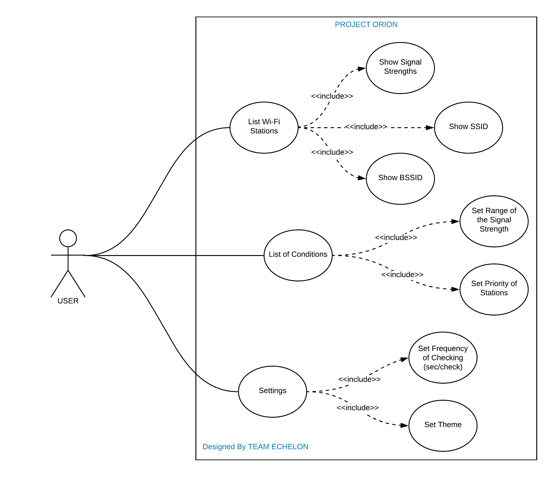

**USER 1:** I am a developer and I live in a big flat. My working space is at the furthest point to the router. For that reason, I am using my old router as an access point but when I go to my room, my phone does not switch automatically to the Wi-Fi which has the strongest signal. I can set the range of signal strength by pressing “List of Conditions” and pressing again to “Set Range of the Signal Strength” so I do not need to make an intervention thanks to the Orion. However, I cannot select the area manually, I hope they will add this option in the future.

|  |  |  |  |
| --- | --- | --- | --- |
| **USE CASE** | **USER STORY 1** | **PRE-CONDITION** | **POST- CONDITION** |
| **List of Conditions** | As a user, I want to set range of the signal strength. | User must give permission to manage the Wi-Fi network control. | User can set the range according to dBm values on Wi-Fi list. |
| **Set Range of the Signal Strength** |

|  |  |  |  |
| --- | --- | --- | --- |
| **USE CASE** | **USER STORY 2** | **PRE-CONDITION** | **POST- CONDITION** |
| **List of Conditions** | As a user, I want to connect my own Wi-Fi’s. | User must check the set priority box | The application connects to the prioritized Wi-Fi’s first. |
| **Set Priority** |

**USER 2:** I was working in a big company, but I have to work at home now due to Covid-19. I bought an access point to place it in ground floor because I want to use my computer in my garden while working. The connection strength is getting weak when I go to the downstairs during the work. In the application, I can set priorities by checking “Set Priority” in “List of Conditions” menu so I can choose my own Wi-Fi’s. That’s why I love Orion.

**USER 3:** There are two access points in my office that placed in different points, but I cannot switch Wi-Fi automatically. I do many phone calls due to my job and need to use my battery efficiently too. I have used many apps to solve this but they drain the battery too fast. Orion has an option which allows setting the checking frequency to reduce battery consumption. It is available in the “Settings” as “Set Frequency of Checking”. That’s why I am using it and recommend to everyone in my office. Also, I could use the application easily but I wish it had a user manual to setup the application for the other users who are not familiar the applications like this.

|  |  |  |  |
| --- | --- | --- | --- |
| **USE CASE** | **USER STORY 3** | **PRE-CONDITION** | **POST- CONDITION** |
| **Settings** | As a user, I want to increase Wi-Fi performance and reduce the battery consumption. | User must enter a value (sec/check). | Application will work periodically depending on the input value. |
| **Set Frequency of Checking** |

**USER 4:** I am a student and have to stay in a dormitory. The dormitory does not have a good wireless technology, there are separate Wi-Fi for each floor but we are not able to connect automatically to the nearest Wi-Fi. And that causes increase of the signal attenuation. To handle this issue, I recommend Orion app to my dormitory friends. In addition, I can set dark theme to take care my eyes from blue lights by going into “Settings” and pressing “Set Theme” but I think design of the application would be more organized.

|  |  |  |  |
| --- | --- | --- | --- |
| **USE CASE** | **USER STORY 4** | **PRE-CONDITION** | **POST- CONDITION** |
| **Settings** | As a user, I want to protect my eyes from harmful blue lights. | User must have at least Android 10 to use the dark theme. | The application runs with dark theme. |
| **Set Theme** |

|  |  |  |  |
| --- | --- | --- | --- |
| **USE CASE** | **ALL USERS** | **PRE-CONDITION** | **POST- CONDITION** |
| **List Wi-Fi Stations** | All users want to list Wi-Fi’s with BSSIDS, SSIDS and their signal strengths. | Users must give the Wi-Fi Management Permission | The application lists the Wi-Fi’s with BSSIDS, SSIDS and their signal strengths. |
| **Show Signal Strengths** |
| **Show BSSID** |
| **Show SSID** |

**NONFUNCTIONAL REQUIREMENTS:**

* **Security**
* **Efficiency**
* **Privacy**
* **Compatibility**
* **Performance**
* **Manageability**

**GLOSSARY**

**Wi-Fi (Wireless Fidelity):** Wi-Fi is a wireless networking technology that uses radio waves to provide wireless high-speed Internet access.

**Signal Strength (dBm):** Signal strength is a measure of how well data is transmitted e.g. via Wi-Fi through electromagnetic waves.

**Router:** A router is a networking device that forwards data packets between computer networks.

**Access Point:** It is a networking hardware device that allows other Wi-Fi devices to connect to wired or wireless network.

**Signal Attenuation:** Signal Attenuation is the loss of signal strength in networking cables or connections.